# TRAFFIC SIMULATOR WORKING DOCUMENT

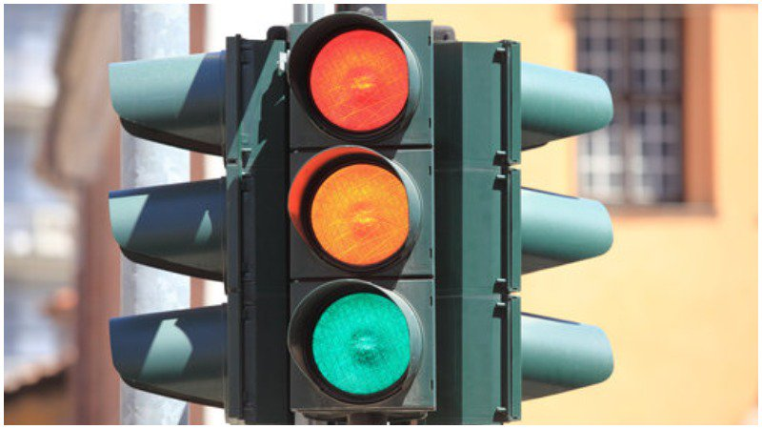

## Class 1: Vehicle class

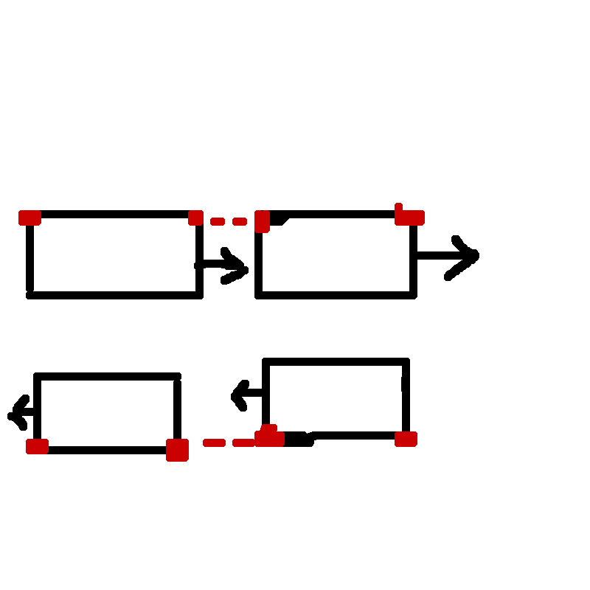

Disregards vehicles in a different direction since they are never going to collide

Vehicles use these to determine if they are about to collide. If not, they will “drive” forward by 1 X/Y value (Depending on direction)

Every Vehicle has a “front” X/Y value and a “back” X/Y value

## Class 2: Road

Roads have 2 ends with X/Y values. Cars will offset from these values when spawning to simulate lanes on the road

## Class 3: T Intersection

If a vehicle reaches the end of the “shorter” road, it will check if anything is in between the “middle” points before randomly turning left or right

T-intersection has X/Y values for both ends of both roads. Also has “middle” X/Y values for collision detection

## Class 4: Cross Intersection

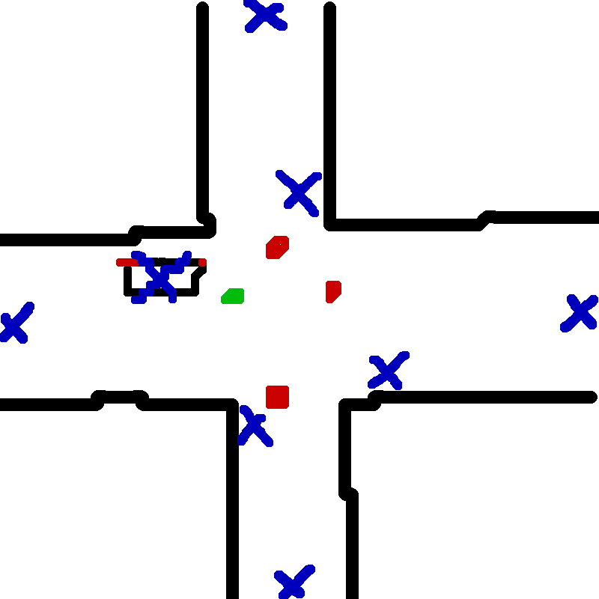

If a vehicle is at the intersection, it will check if the light is green for them, then it will decide to go left, right or forward. If turning, it will offset itself from the “middle” point on that section

Like the T-intersection, each road has X/Y values for their ends and “middle” X/Y values